Name: B.HRITHIK

Roll No:2420030502

9.STATIC CODE ANALYSIS USING SONARQUBE
Java Duplicate Code and Maintainability Analysis

Objective
To perform static code analysis of a Java program using SonarQube, identify duplicate code and maintainability issues, and verify the analysis results before and after improving the code.

Software and Requirements
  - Windows operating system
  - Java JDK installed
  - SonarQube Server installed locally
  - SonarScanner CLI installed
  - A Java source file containing duplicate statements
  - Web browser

Project Folder Structure
Create the following project structure:
C:\Users\DELL\sonar-java-demo\src\main\java\DuplicateCode.java

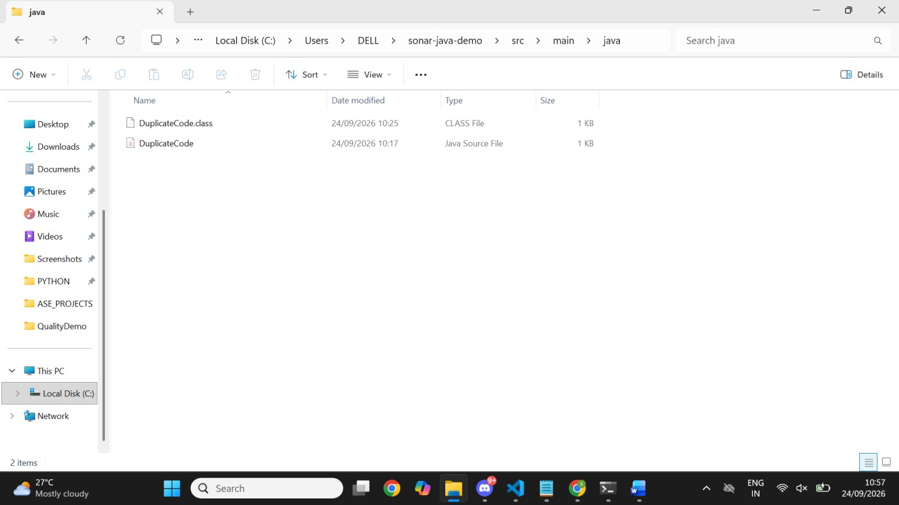

Create the Initial Java Program
Create a file named DuplicateCode.java and add the following code:
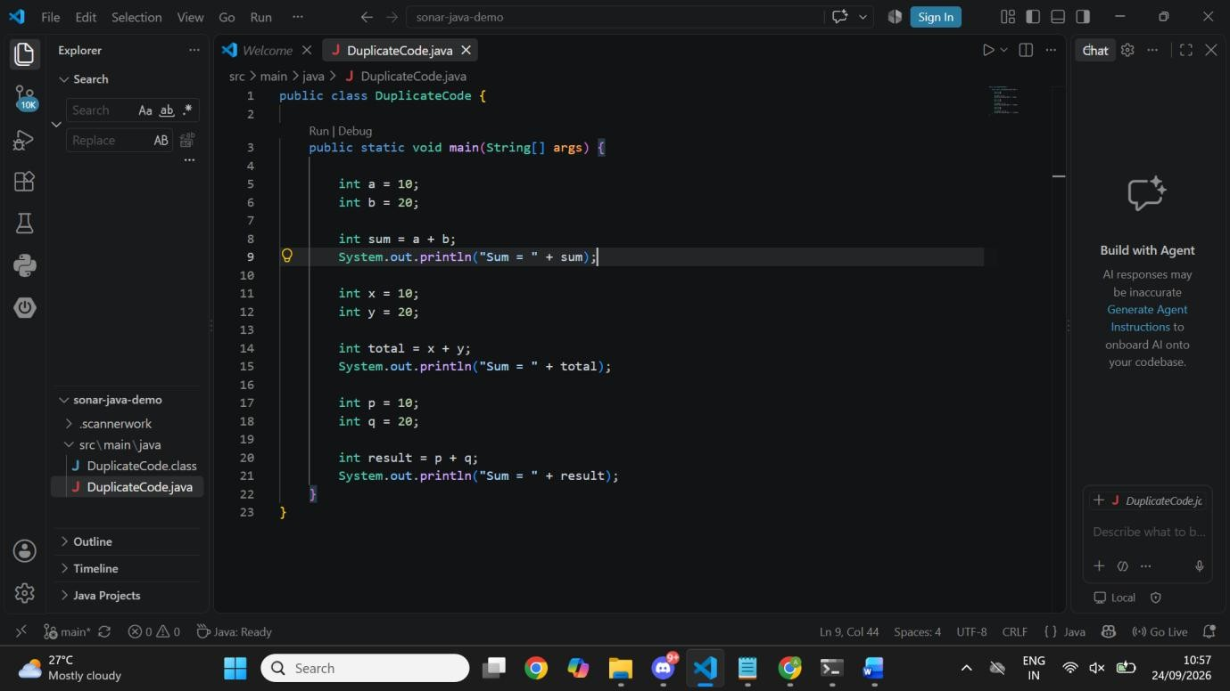

and Run the Java Program
Open Command Prompt and execute:

cd /d C:\Users\DELL\sonar-java-demo javac src\main\java\DuplicateCode.java java -cp src\main\java DuplicateCode
Expected output:
Sum = 30
Sum = 30
Sum = 30
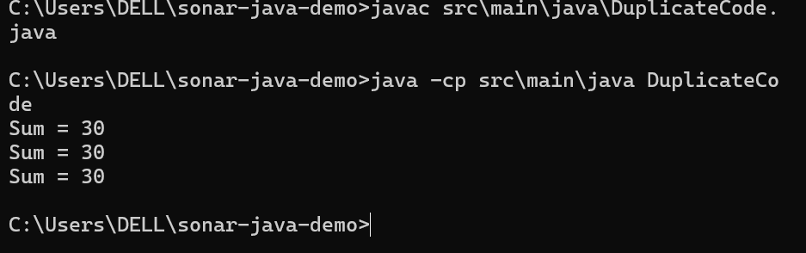

Start SonarQube Server
Open Command Prompt and run:
cd /d C:\Users\DELL\sonarqube-26.9.0.129388\bin\windows-x86-64 StartSonar.bat
After the server starts, open http://localhost:9000 in a browser and log in to SonarQube.
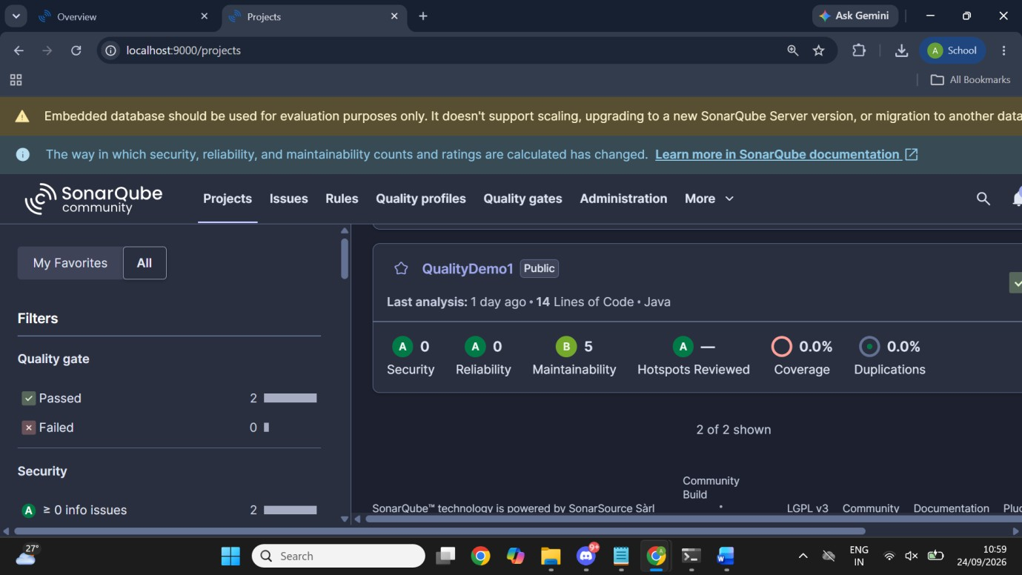

Create the SonarQube Project
Create a local project in SonarQube. Use the project name:
Java Duplicate Code Analysis
The project key used for the successful analysis is:
Java-Duplicate-Code-Analysis
For the new-code definition, the instance default (Previous version) can be retained.

Generate a SonarQube Analysis Token
Generate an analysis token in SonarQube and keep it private. Do not include the token in screenshots or in this report.

Verify SonarScanner Installation
Run:
sonar-scanner -v

The command should display the installed SonarScanner CLI version and the operating system information.

Run the First SonarQube Analysis
Open Command Prompt and run the following from the project directory:
cd /d C:\Users\DELL\sonar-java-demo
sonar-scanner -Dsonar.projectKey=Java-Duplicate-Code-Analysis -Dsonar.sources=src/main/java -Dsonar.host.url=http://localhost:9000 - Dsonar.token=YOUR_NEW_TOKEN

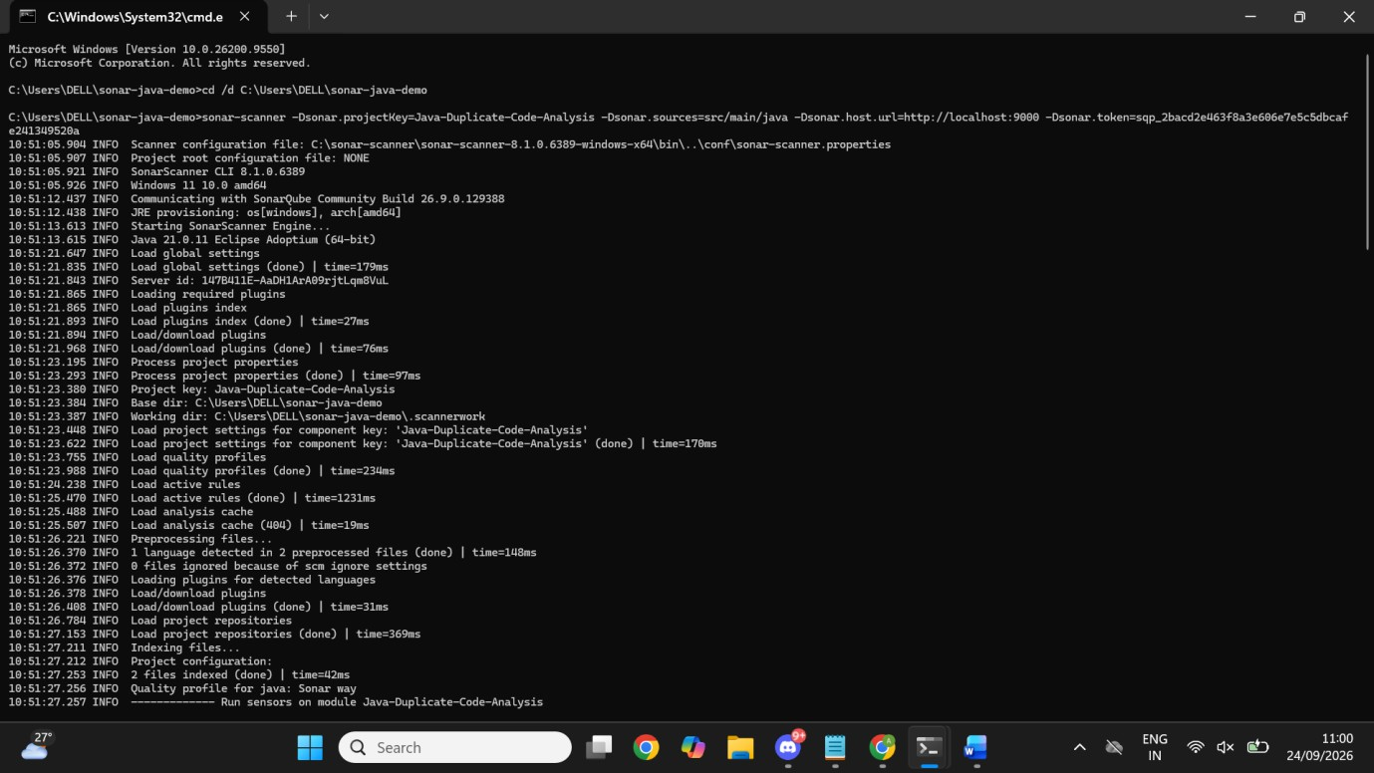

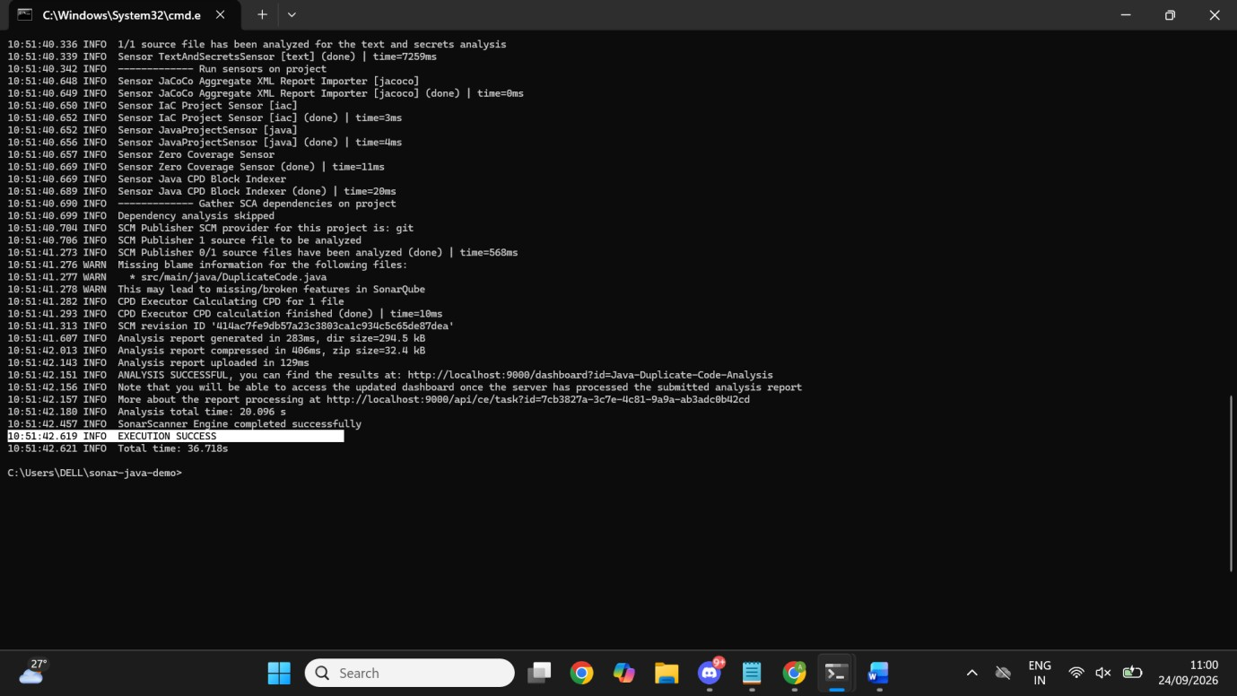

Open the SonarQube Dashboard
Open the project dashboard in SonarQube. The project URL used in this project is:

http://localhost:9000/project/dashboards/built-in/project-health?id=Java-Duplicate-Code-Analysis
The initial analysis showed 16 lines of code, Security A with 0 issues, Reliability A with 0 issues, Maintainability B with 5 issues, 0.0% coverage, and 0.0% duplications.
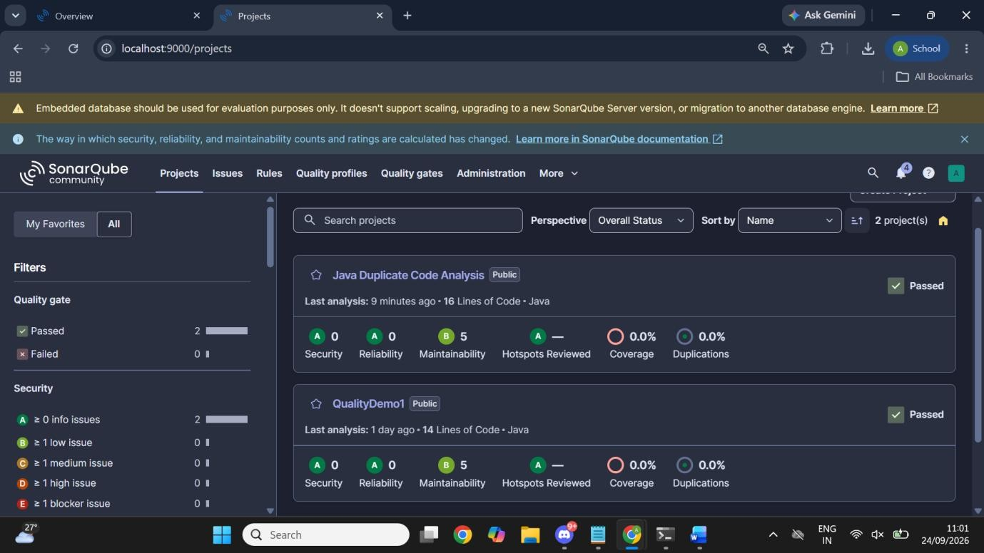

Conclusion
SonarQube can be used for static code analysis of Java applications to identify code-quality problems such as maintainability issues and code duplication. The project demonstrated the complete process of creating a Java program, running SonarQube analysis, reviewing the dashboard, identifying repeated code, and refactoring the program to improve maintainability.



   

